Prescribing Tip For Information
Lipid Modification for Secondary Prevention of Cardiovascular Disease (CVD)
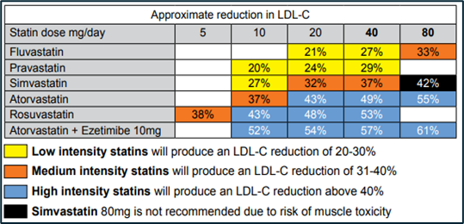
Patients with established CVD should be taking a ‘high intensity’ statin if tolerated. A high intensity statin is one which will produce a minimum of a 40% reduction in Low Density Lipoprotein (LDL) cholesterol.
- NICE recommends Atorvastatin 80mg daily as the first line choice for Secondary Prevention.
- The table above is from the Lipid Management Pathway which shows the various intensities of statins at different doses.
- NICE guideline NG238 suggests that clinicians should be reviewing patients who are on statins and to ‘consider increasing the statin intensity/dose if the person is not currently taking a high intensity statin at the maximum tolerated dose’.
- For patients who are struggling to tolerate a statin or experiencing side effects, please refer to the Statin Intolerance Pathway which gives recommendations on assessing statin related side effects, when to calculate Creatinine Kinase and when to consider a re-challenge and restart statin therapy.
There are now targets in place for Secondary Prevention of CVD in patients taking lipid-lowering treatments in NICE guideline NG238 and in QOF target CHOLOO4.
- The aim is to achieve LDL cholesterol levels of 2.0mmol/L or less, or non-HDL cholesterol levels of 2.6mmol/L or less.
- If target levels are not achieved and the patient is on the maximum tolerated dose of statin, or if a statin is not tolerated, then consideration is needed to commence additional lipid-lowering therapies.
- In addition to the maximum tolerated dose of statin, Ezetimibe 10mg solely, or if target levels are not achieved, Ezetimibe in combination with Bempedoic Acid 180mg, can be initiated in Primary Care. If Ezetimibe is not tolerated, Bempedoic Acid can be used as monotherapy.
Injectable therapies can be considered if the LDL cholesterol is persistently raised on a fasting blood test. If LDL cholesterol remains above 2.6mmol/L despite optimal lipid-lowering therapies mentioned above, then Inclisiran can be considered. Inclisiran is Green Restricted on our local formulary and is therefore suitable for prescribing in Primary Care if certain criteria are met. The specified criteria can be found on the LSCMMG website in the Inclisiran Position Statement.

If the LDL cholesterol remains above 4.0mmol/L (or 3.5mmol/L if patient is very high risk and has had recurrent cardiovascular events) then the patient will require a referral for consideration of a PCSK9 inhibitor. Both Alirocumab and Evolocumab are Red on our local formulary and are not suitable to be prescribed in Primary Care.
Icosapent ethyl is Green Restricted on our local formulary and can be considered in Primary Care if the patient has raised triglycerides, if certain criteria are met. The patient needs to be on statin therapy, have established cardiovascular disease, a fasting triglyceride level of 1.7mmol/L or above and an LDL cholesterol level between 1.04 – 2.6mmol/L.
The above information is summarised in the Secondary Prevention Flowchart on the LSCMMG website.

